1. **Create docker file for nginx:**

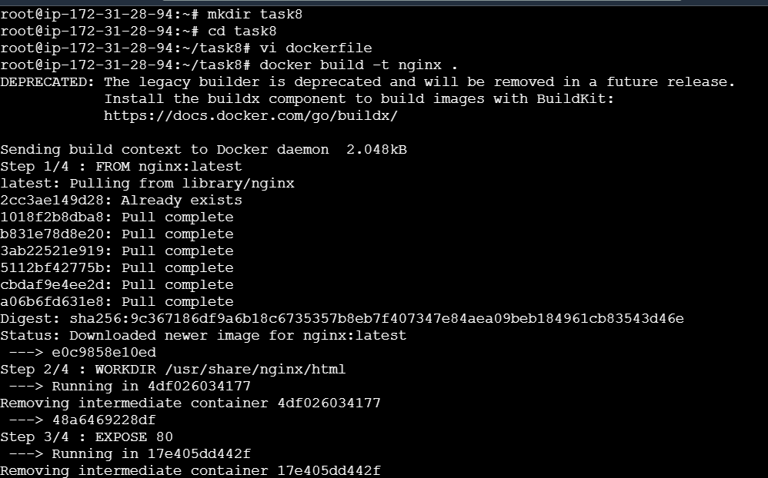

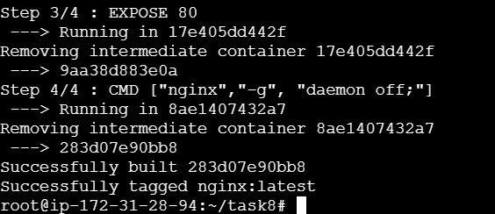

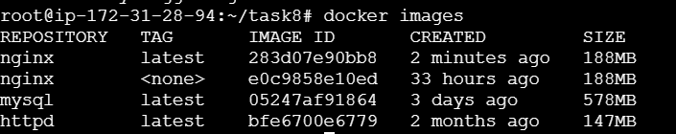

1. **Run custom docker images:**

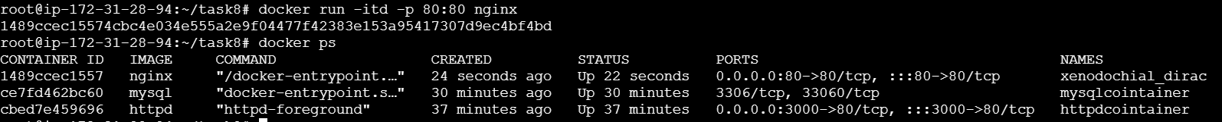

**Default nginx page:**

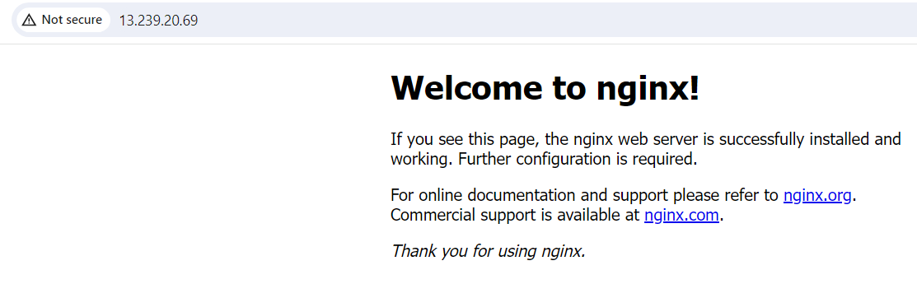

1. display basic details in website:

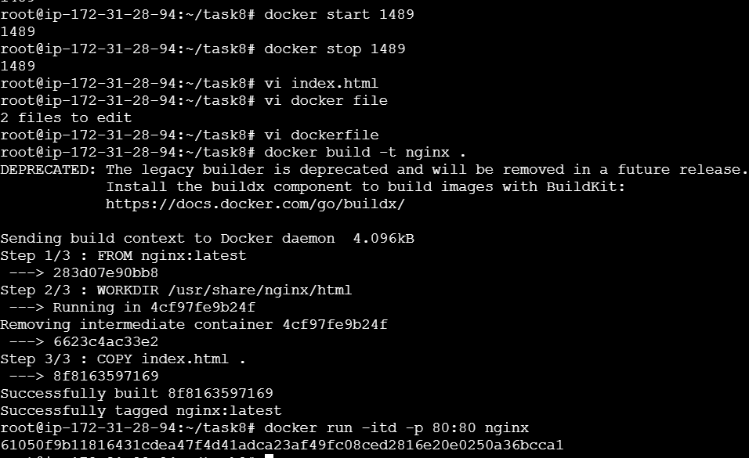

**Index.html file :**

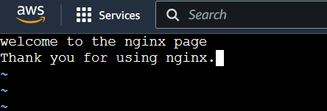

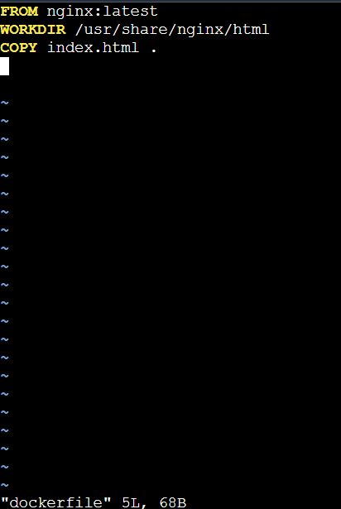

**display basic details in website:**

